**Question 1**

1. Bespoke product. This food ordering system is developed for the Crispy & Crunchy restaurant where the copyright will belong to its owner, Mr Steve. Moreover, the requirements specification will be controlled by the restaurant owner, Mr Steve. To illustrate, 4 main modules *(customers account management, online staff account management, online food ordering and payment, and online food catalogues management)* will be developed according to the requirements specified by Mr Steve.
2. Rapid Application Development. It is an incremental software process model that emphasizes an extremely short development cycle.

Justification:

* The user requirements are clearly defined. (4 main modules to be developed for new food ordering system)
* It could be modularized easily which can be divided into 4 modules *(customers account management, online staff account management, online food ordering and payment, and online food catalogues management)*
* Restaurant owners request the system to be ready within three months.
* Since this project is ranked as high priority, the 8 senior software engineers can be divided into 4 teams in which 2 people in a team develop each of the modules within 3 months.
* **Efficient** – The system performs those functions efficiently in terms of time and resources. For example, food ordering system shall be able to process payment within 1 second
* **Reliable** – The system will not be prone to hardware or software failure and it will deliver the functionality whenever the users want to execute it. For example, food ordering system’s failure rate shall be less than 0.5% per year
* **Secure** – The system is protected against errors, attacks, and loss of valuable data. For example, food ordering system shall protect private information of the customer such as personal and credit card information

**Physiological**

* We will provide good employment or comfortable working condition, regular monthly salary. For example, Wi-Fi access to ease the internet connection or tea/coffee making facilities

**Safety**

* We will emphasis a healthy and safety working environment by having formal contract to our senior engineers and benefits such as sick pay and pension

**Question 2**

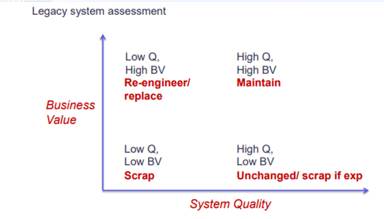

The legacy system should be re-engineered because it has high business value (the draft contents might be useful in the future to trace the original story) but low quality (no proper documentation and module design).

1. -

| **Characteristic** | **Maintenance Cost** | **Reason** |
| --- | --- | --- |
| No proper documentation | High | The low quality of documentation will make it difficult for developers to understand the code. Hence, they will need to spend more time on it. |
| No proper module design | High | High dependency of module will result in when a module is changed, other modules which are dependent on it will be affected |

1. System organization that is suitable for this legacy system is the **repository model**. All shared data is held in a centralized database. Repository model is suitable when there are large amounts of data to be shared.

Justification

* The data is to be shared throughout the organization
* Since the file storage system was developed in 1960s which is long time ago, there should large pool of draft content stored

1. -

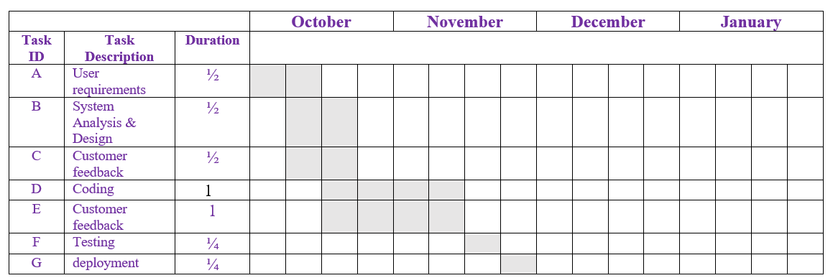

Question 3

1. -

**Functional requirements**

* The system shall allow the users to check the availability of the facility
* The user can select the available facility and and make a booking
* The user can check the availability for the book they want to borrow
* The system shall send reminder to the user when the return date of a book is overdue
* User can make a paper photocopy at the photocopying machines after login using electronic identity (e-ID)

**Non-Functional requirements**

* **Reliability** - TAcademy computerized services system downtime should not be more than 0.05%.
* **Usability** - TAcademy computerized services system should be easy to navigate from page to page and have a very low learning time.

1. Module testing is to test the collection of individual components that combined into a module whether they can function properly while for the stress testing is to test the system to ensure it can support the intended load

**Module testing.** It is a testing technique that tests the collection of the individual components to find out whether they are functioning correctly after integrating into the module.

| Program name: TAcademy computerized services  Test date: - | | | | | |
| --- | --- | --- | --- | --- | --- |
| No. | Test case | Test data | Expected Result | Actual Results | Remarks |
| 1 | To test the facility booking module of the TAcademy computerized services system | Booking data | The system should process the booking successfully and display the booking confirmation message to the user | - | - |

**Stress testing**

| Program name: TAcademy computerized services system  Test date: - | | | | | |
| --- | --- | --- | --- | --- | --- |
| No. | Test case | Test data | Expected Result | Actual Results | Remarks |
| 2 | To test the accessibility of the system when it is fully loaded with facility booking data, book return and borrow data. | Student booking data  Book return and borrow data | The system should not get slow and deliver the function well even it’s full of service data | - | - |

1. -

**Business process engineering tools -** E.g Flowchart to trace and track the data flow between different original departments

**Data modeling tools** - E.g *Database management system (DBMS)* to manage and store the related data in the database such as payment, product, order, order details, customer and etc

Question 4

Stimuli (Play button is pressed) ->Response (Play Video streaming)

Stimuli (Pause button is pressed) ->Response (Pause video streaming)

1. (i)

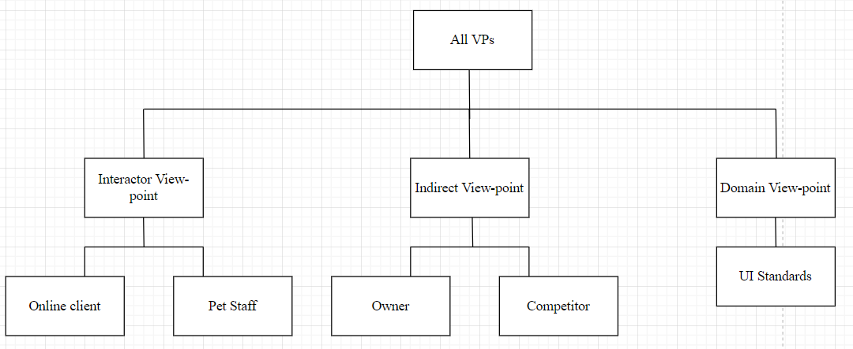

(ii)

**Recoverability**

* TAcademy's computerized services system should allow the user to reverse some actions such as an undo function if the user clicks the button (i.e add to cart button) accidentally. Hence, the user knows that error can be undone and this will relieve their anxiety and also encourage them to explore some unfamiliar options in the system

**User guidance**

* TAcademy computerized services system should provide necessary help and offer informative feedback when users perform a wrong action in the system. The error message should be human-readable, polite and constructive to suggest a solution to the user so that they can solve it easily without getting frustrated.

**Consistency**

* The similar operation should be carried out in the same way so that it won’t confuse the user. For example, the navigation control/bar of the TAcademy computerized services system should be consistent by using the same button, command or hyperlink to trigger its function (i.e., facility booking, borrow/return book) within the system.

**Minimal surprise**

* The system should behave as expected and not give the user any surprise as the user wants the system to be in control at any time. For example, TAcademy computerized services systems should not shut down unexpectedly when users are performing an action within the system such as making payment. This could let them confuse and feel anxiety as they don’t know their action has been carried out successfully or not.
* Cohesion focuses on how much the functionalities are close to each other within a module while coupling focuses on how much a module depends on another module within the whole system.
* High coupling means that the module is highly dependent on another module. They cannot function well without another. Hence, during the maintenance process, software engineers will need to maintain both modules which increase maintenance cost.
* Low cohesion means that the modules are not logically connected which will make the module complex and reduce system maintainability which increases maintenance cost.
* In conclusion, *low cohesion* and *high coupling* will result in high maintenance cost.